

DUPLICATION REMOVAL

Computer project



SoURADEEP MONDAL

# ACKNOWLEDGEMENT

I would like to thank Ms. Archana Jain for her valuable guidance which helped the project to be a success. Her suggestions served to be a major contribution to the project.

I would like to thank my parents for helping me test push my skills further.

I would also like to thank my friends for their challenges that helped me hone my skills.

# CONTENTS

* Overview
* Concepts used
* System requirements
* Code
* Output
* Bibliography

# Overview

This software was developed for Markswell Pvt. Ltd. The company requested a software to aid in duplication removal of their employees from their master files.

This issue comes up due to manual errors during data entry.

To handle the problem, the company requested for a software as a solution to identify the duplicate names entries so that they can identify the correct entry for retention.

# Concepts used

The development of the following software required the knowledge of following concepts :-

* Data file manipulation
* Pointers
* Data file input and output
* String manipulation

# Hardware and Software needed

## *Hardware*

* Min 864 MB RAM
* Min 890 Mhz processor
* Monitor
* Keyboard

## *Software*

* Turbo C++ v 1.1.3 or newer
* Ms Windows XP or newer/Linux(16-bit compatible)

Note: turbo C++ does not run directly on current version(s) of windows 10. A separate interface or a modded version is required.

# CODE

## CODE 1 – program to take user input and place the id and names into a file. (proj1.cpp)

#include<fstream.h>

#include<conio.h>

#include<stdlib.h>

#include<string.h>

struct input

{char name[11];

long id ;

};

void main()

{ input o; char ans; clrscr();

fstream in;in.open("input.txt",ios::out|ios::app|ios::binary);

do

{ cout<<"enter ID:";

cin>>o.id;

cout<<"enter name:";

cin>>o.name;

in.write((char*)&o,sizeof(o));

cout<<"enter more(n/y):";

cin>>ans;

}while((ans=='y')||(ans=='Y'));

getch();

in.close();

}

## CODE 2 – program to read the file created in program 1 and identify the duplicate names. These are copied into a new separate file. (proj5.cpp)

//program to identifu copies

#include<fstream.h>

#include<conio.h>

#include<string.h>

#include<iostream.h>

struct data

{ char name[11];

long id;

};

void main()

{clrscr(); data d1,d2,temp; int point;

fstream in,in2,copy,copyid,out;

in.open("INPUT.TXT",ios::in|ios::binary);

copy.open("copy.txt",ios::out|ios::binary);

while(!in.eof())

{ loopset:

in.read((char*)&d1,sizeof(d1));

point=in.tellp(); //get current position

strcpy(temp.name,d1.name);

temp.id=d1.id;

in2.open("INPUT.TXT",ios::in|ios::binary);

in2.seekp(point,ios::beg);

while(!in2.eof())

{

in2.read((char*)&d2,sizeof(d2));

if((strcmpi(temp.name,d2.name))==0)

{ copy.write((char*)&d2,sizeof(d2));

}

else

continue;

}

in2.close();

}

cout<<endl<<"done";

getch();

}

## CODE 3 – this program is to display the contents of the duplicate file for review by the company (proj3.cpp)

//to show output of copy file

#include<fstream.h>

#include<conio.h>

struct frame

{char name[11];

long id;

};

void main()

{ clrscr();

fstream copy,out; frame s,u;

gotoxy(0,20);cout<<"COPY REMOVAL"<<endl;

copy.open("COPY.TXT",ios::in|ios::binary);

cout<<"COPIES "<<endl<<endl;

while(!copy.eof())

{ copy.read((char*)&s,sizeof(s));

cout<<"name:"<<s.name<<" ID:"<<s.id<<endl;

}

copy.close();

getch();

cout<<"--------------------------------------------"<<endl;

getch();

}

## CODE 4 – this program is to search for an ID through name and find the size and no of ID’s in the input or output file

/*flie size and searching*/

#include<iostream.h>

#include<conio.h>

#include<string.h>

#include<stdio.h>

#include<fstream.h>

struct input

{char name[11];

long id;

};

void main()

{clrscr();

long int p,contacts,a; int c;

input l;

fstream myfile;

char ifile[14],ufile[14],name[11];

start:

gotoxy(20,1);

cout<<" file search and size";

gotoxy(1,3);

cout<<"menu"<<endl<<"1.file size and no. of records"<<endl<<"2.searching in file\n3.exit"<<endl;

cin>>a;

switch(a)

{ case 1:goto sizes;break;

case 2:goto search;break;

case 3:goto end;break;

default:{cout<<"wrong input\n";getch();clrscr();goto start;}

};

sizes:

{ s1:

cout<<"select file from list \n1.input file\n2.copies file\n";

cin>>c;

if(c==1)

{myfile.open("INPUT.TXT",ios::in);}

else if(c==2)

{myfile.open("COPY.TXT",ios::in);}

else

{cout<<"wronginput";getch();goto s1;}

myfile.seekg(0,ios::end);

p=myfile.tellg();

contacts=p/sizeof(l);

cout<<"size:"<<p<<endl;

cout<<"no. of contacts:"<<contacts<<endl;

getch();

clrscr();

myfile.close();

goto start;

}

search:

{ s2:

cout<<"select file from list \n1.input file\n2.copies file\n";

cin>>c;

if(c==1)

{myfile.open("INPUT.TXT",ios::in);}

else if(c==2)

{myfile.open("COPY.TXT",ios::in);}

else

{cout<<"wronginput";getch();goto s2;}

cout<<"enter name to search:";

cin>>name;

while(!myfile.eof())

{ myfile.read((char*)&l,sizeof(l));

if((strcmpi(l.name,name))==0)

{ cout<<"name:"<<l.name<<endl;

cout<<"ID:"<<l.id<<endl;

}

else

continue;

}

getch();

clrscr();

myfile.close();

goto start;

}

end:

getch();

}

# OUTPUT

 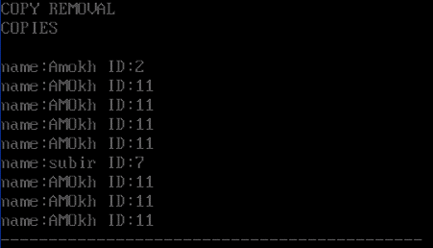

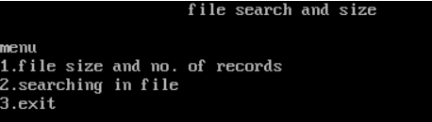 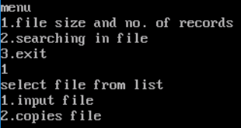 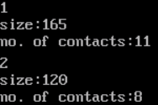

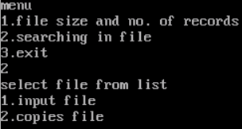 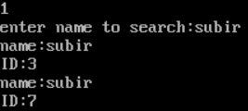 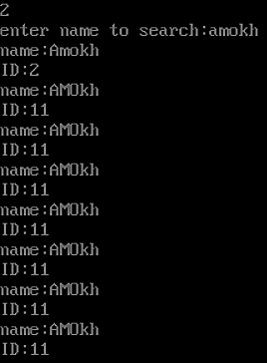

# BIBLIOGRAPHY

* Cncpp.divilabs.com
* Thecrazyprogrammer.com
* Codescope.com